Guidance for children and young people, families and professionals facing unwanted or hurtful online messages

Social Media apps can be a great way for children and young people to talk to friends, but cyberbullying is a growing issue that many children and young people face.
There are a few simple steps children can take to protect yourself themselves.
Most social media platforms allow you to block any comments and report and block profiles that are sending you negative or unpleasant messages.
When you block someone, it means they are unable to see anything you post, and you can’t see their profile, comments or messages either.
You can do this in the “settings” section of whatever app you are using. If you’re not sure how to do this, ask a trusted adult to help you.
If you’re being added into group chats that you don’t want to be in, block the numbers which are adding you and exit all the groups.
It can be hard but try not to get involved in the chats. Take screenshots of any hurtful messages instead.
Make sure you screenshot everything said to you before blocking anyone as you might need this as proof, to evidence what’s happening.
If you feel unsafe, always tell someone. Make sure you take these concerns to an adult you trust and let them know what’s been going on.
If you’re being threatened with violence, either online or offline, you should contact the police.
The most important thing is to not suffer in silence.
Consider Ignore, Block, Report when dealing with unwanted or hurtful messages.
There are excellent resources that you should take a look at:

‘Own It’ App
‘The BBC is launching a new app to try and help the wellbeing of young people online. It's called Own It and it encourages young people to stop and think before they hit the send button.It monitors how they interact with their friends and family online and uses artificial intelligence to try and see how a child is feeling.’
The APP can be found here: https://www.bbc.com/ownit/take-control/own-it-app

“Being Bullied? Five things you need to do RIGHT NOW!”
https://www.bbc.com/ownit/curations/bullying-and-trolling

Internet Matters, step-by-step guides to set controls on popular social media apps
https://www.internetmatters.org/parental-controls/social-media/
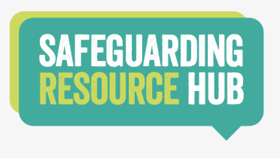
The Safeguarding Resource Hub provides additional resources that can support children, young people, parents/carers and professionals:
https://www.safeguardingresourcehub.co.uk/

And don’t forget you can also contact Childline on 0800 1111
https://www.childline.org.uk/

